Fall 2017
Injury Prevention and Control
Public Health 285A
2 units (3 units with a paper)
Meets weekly on Friday, 2-4 pm, Giannini 332

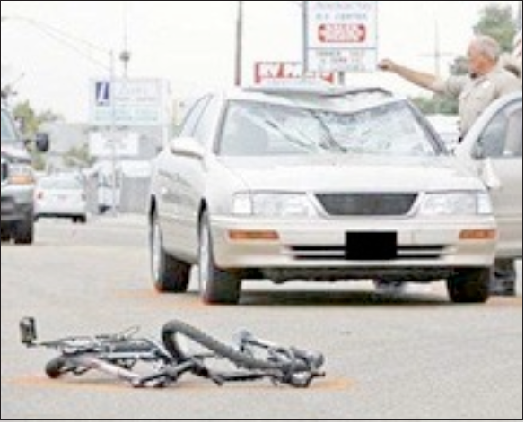 | Course Overview:  Injury is the leading cause of death for ages 1-44, and the leading cause of years of potential life lost to age 70, surpassing heart disease and cancer. The general topic of injury is very diverse, including unintentional and intentional injury. The semester will begin with an overview of the field of injury followed by a focus on several specific subject areas, examining current issues within those subject areas. A systems approach to injury prevention will be emphasized throughout. Course activities include discussion based on key readings, web-based and observational assignments, and a paper and presentation at the end of the semester. An extra-unit is available for students who wish to prepare a paper for publication.

Public Health Burden of Injury
- Unintentional or intentional damage to the body resulting from acute exposure to thermal, mechanical, electrical, or chemical energy or from the absence of such essentials as heat or oxygen.
- Leading cause of death for ages 1-44, and leading cause of potential years of life to age 70.

Course Aims
- Knowledge and understanding of injuries as a major public health problem. (size and scope of the problem, social costs of injury, financial burden to health care system).
- Understanding of methods and approaches in injury epidemiology (measuring exposure, risk assessment, models of accidents and injury.
- Understanding of current methods and approaches of controlling injuries, with an emphasis on systems approaches.

Topics for Fall Semester 2017
- Overview (Definition, scope of the burden of injury, sources of data)
- Motor vehicles (a leading cause of U.S. injury deaths)
- Pedestrian and bicyclist Injury (critical issue mode shift to walking and biking)
- Firearms (a leading cause of U.S. injury deaths)
- Occupational injury (social and economic impact, role of worker’s compensation)
- Global impact of injury (traffic injury, injury from military/political conflict)
Each of these topics, in addition to being of great importance in their own right, illustrate the role of data and information in understanding injury and injury prevention.

Course Requirements/Activities
- Readings, attendance, and participation in class
- Class exercises
- Class project: Brief paper on a current injury topic; PowerPoint presentation summarizing the paper. (Optional, one credit): Extended paper in style of publishable manuscript.

Instructor: David Ragland, PhD, MPH,
Safe Transportation Research & Education Center, http://safetrec.berkeley.edu/
School of Public Health, Office: 2614 Dwight Way #7374, Tel: 510-642-0655, davidr@berkeley.edu

Glenn Shor, PhD MPP
Center for Occupational and Environmental Health, UCB School of Public Health, Office: 2614 Dwight Way #7374, Tel: 510-292-8449, gshor@berkeley.edu

