Spring 2018
Traffic Safety and Injury Control

Civil and Environmental Engineering C265
(Cross-Listed with Public Health C285)

3 Units (course #: 42338)
Tu-Th 3:30-5PM 31 Evans

Injuries from traffic crashes are a major cause of death and disability in the United States and around the world. In the United States injury from traffic crashes is the leading cause of death and disability for people ages 1 to 34, and a major cause for all age groups.

The course will examine principles of engineering and behavioral science relevant to preventing traffic collisions and subsequent injury. Human behavior, vehicle design, and roadway design will be considered as components of a Safe Systems approache to preventing traffic crashes and injuries. Safety of vulnerable road users (primarily pedestrians and bicyclists) will be covered extensively.

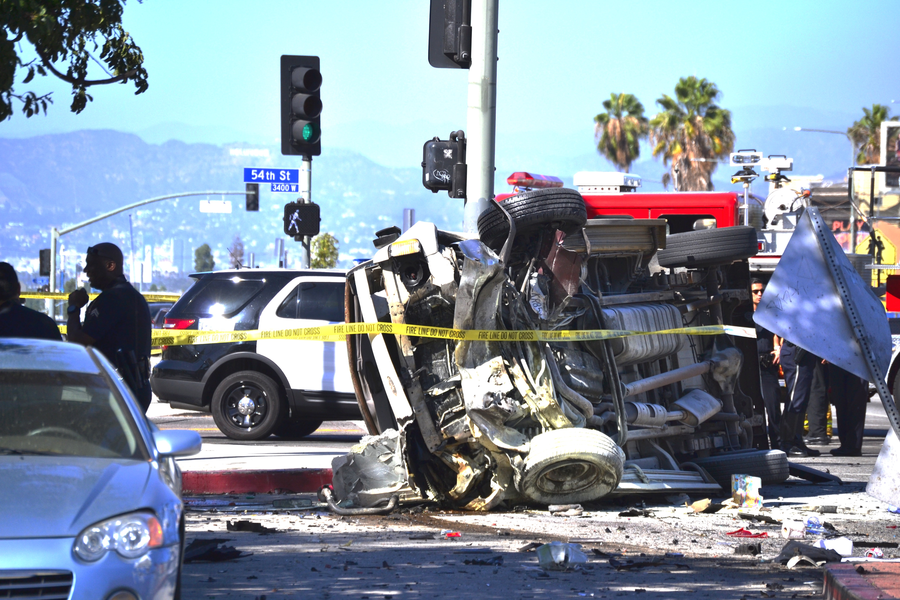
Given the rapid emergence of technology—self-driving vehicles, crash avoidance systems, vehicle-infrastructure integration—we will have a two-week module on the implications for safety (for all modes) of these emerging technologies.
Specific skill sets developed in the class:
- Identify crash causal factors
- Analyze collision risk in a road network
- Identify and evaluate countermeasures
- Determine safety implications of self-driving vehicles and other emerging technologies
Class grade will be based on homework assignments (30%), participation (20%), and a research paper (50%). The research paper is often successfully submitted to conferences and journals after the class has ended.

This course is open to students of all academic backgrounds. Undergraduates welcome; please contact instructor for permission.

Instructors:
Offer Grembek, PhD (UC Berkeley) grembek@berkeley.edu
Safe Transportation Research and Education Center (SafeTREC), affiliated with the Institute of Transportation Studies and the School of Public Health)

David Ragland, PhD, MPH davidr@berkeley.edu
Safe Transportation Research and Education Center (SafeTREC)

GUEST LECTURER
Koohong Chung, PhD (UC Berkeley), PE koohong@gmail.com
California Department of Transportation

